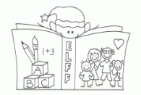
ATTENTION PARENTS OF 3 & 4 YEAR-OLDS!
You and your family are invited to join us for…
ELFF & Ready, Set, Learn
Early Learning for Families & the Ready, Set, Learn Program are creating a great event taking place at
École Élémentaire Casorso Elementary School
THURSDAY, APRIL 11TH @ 4:00 – 5:30 pm

“When parents are involved in the children’s education, their children do better. ELFF is a program for families of 3 year old children designed to improve their success in literacy and to build connections between home and school”.
Brought to you by School District No. 23 and
ReadNowBC (Ready, Set, Learn)
We will……
- Eat supper together (pizza)
- Learn together while the children play
- Play together while our children learn
- Make and take special things home
- Give you a “goodie bag” for home

ELFF is free of charge for all members of your family. Childcare will be provided along with supper for all of you.
If you plan to attend, please use the following QR code to access the registration form before 3:00 pm on MONDAY, APRIL 8TH
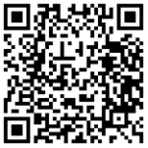

For any questions please call the school @ 250-870-5135.

